Brake disc end face precision grinder
Operating instruction
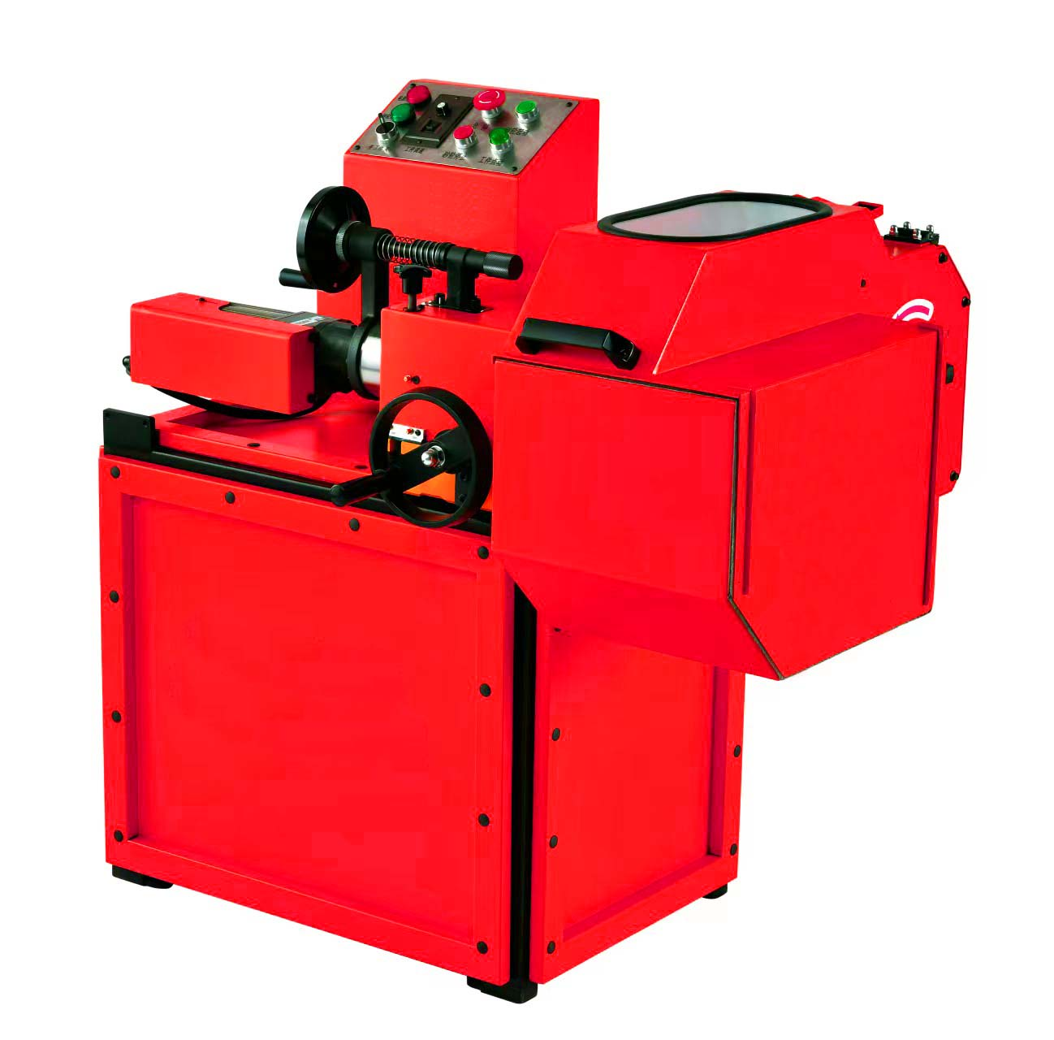

Contents

1. Introduction of the machine and the main technical parameters 2
2. Equipment lifting, movement, and installation. 3
Equipment lifting 3
Move the work site 3
Equipment installation and fixation 3
3. Instructions for the safe use of the equipment 3
4. Operation button position function, hand wheel function to feed the use method. 4
Electrical device button control part 4
Use the method of the hand wheel 6
5.Start-up check, refuel the lubrication point, and confirm the rotation direction of the grinding wheel shaft and workpiece shaft. 6
Fill with lubricating oil 6
Confirm the rotation direction of the grinding wheel shaft and the workpiece shaft 6
6. Grinding brake disc operation steps, accuracy adjustment, common problems and solutions in the operation method. 7
Operation steps of grinding the brake disc 7
Precision adjustment 8
Common problems and solutions in the operation 8
7. Daily maintenance and warranty terms 8
Daily use and maintenance of precision brake pad 8
Warranty terms 9
8.Attachment 9

1. Introduction of the machine and the main technical parameters
The brake disc end surface precision grinder is specially designed and made in the field of civil automobile repair brake disc. It has compact structure and covers little space. The brake disc finish by the grinder is with high precision. The accuracy and appearance after trimming can be comparable to the brake disc state when the new car leaves the factory. The grinder operation is simple and intuitive, and the precision is easy to control.

Technical parameters
Overall packaging dimensions  Gross weight | L*W*H: 1270 * 920* 1220 mm  225 kg
Installation and usage size  Net weight | L*W*H: 1050 * 720* 990 mm  178 kg
Wiring mode  Voltage | 4 - line  380V + 220V
Power of motor | 1.5 kW / 120 W
Maximum installation size of disc | 420 mm in diameter
Maximum grinding size of disc | Diameter: 420mm/Thickness: 42mm Width: 100 mm
Grinding brake disc working face axial offset | ≤0.005 mm
Surface roughness | ≤0.8μm
Grinding and machining speed (piece*) | 5 - 8 min/disc ( Diameter 350 - 400 mm)
Grinding wheel speed | 2800 rpm
Workpiece speed | 120 / 200 / 500 rpm

Note.: * is about the average grinding time during large - scale repeated grinding of all types of brake discs.

2. Equipment lifting, movement, and installation.

Equipment lifting
If the equipment is not unpacked, the net weight of the equipment is 175 kg, and the weight of the packaging wooden box and the machine is about 195 kg. Choose a suitable lifting tool. When using lifting tools such as the crane and forklift, it is necessary to confirm the center of gravity marked in the packaging of the wooden box and reasonably distribute the key points.

Move the work site
When the equipment is unpacked, use the two lifting tools in the random attachment--lifting handle and lifting lever. When moving with human labor, the lifting handle is a key point and two key points at both ends of the lifting lever (the lifting lever is inserted in the machine rack and rubber cushion gap, see marked in Figure *). When handling with lifting tools, attention should be paid to the position of the center of gravity marked by the machine and the rope should not touch the protective cover of the machine to avoid damaging the protective cover.

Equipment installation and fixation
According to the distribution position of the equipment center of gravity, the equipment shall be installed and fixed with four anchor bolts and nuts (anchor bolts longer than 20cm), and four holes for the anchor bolts under the equipment frame. In special circumstances, when the test machine is not fixed with the ground, special attention should be paid to the position of the center of gravity of the equipment, otherwise it may cause equipment dumping and accident, and may cause personal injury and damage to the equipment.

Instructions for the safe use of the equipment
Read the instructions carefully and completely. Before using the equipment, read the instructions carefully and understand the meaning of the instructions, and operate according to the instructions, so as to avoid accidents caused by improper operation, and cause personal injury and equipment damage.

Use electricity safely, install the grounding wire, and connect to the wire.
Before the equipment is connected to the external power line, determine the working position of the equipment. It must be grounded first, and the grounding line must be affixed with the grounding mark. Select suitable terminals, copper cable greater than 4 square meters, both ends of the cable connected to the terminals, and tin welding reliable. Grounding facilities, 1: common grounding connection of the work site, 2: conductive metal with terminals such as 10 round steel or 1.5 by 1.5, inserted into the underground depth of greater than one meter. One end of the wiring terminal is connected to the wiring bolt of the equipment protection grounding, tightened with a nut, and the other end is connected to the grounding facility, and confirm the connection is reliable conduction.
Access to the external power line, the equipment power supply is four lines, three - phase 380V + 0 line, operation torque 220 V control, power lamp 220V, motor equipment is 380 V and 220 V.
The external power supply access position and wiring terminal are reserved in the equipment electrical box. The three - phase three - line 380 V power cord is connected to L1, L2 and L3 terminals respectively, and the zero line is connected to the N terminal.

After connecting to the power cord, confirm that the connection is reliable and the wire does not contact the equipment housing. Quickly press the grinding wheel to stop the grinding wheel, or press the workpiece point to press the testing machine to confirm whether the rotation direction of the grinding wheel and workpiece is correct.
During equipment maintenance, we must confirm that the equipment power supply and the power lines above the equipment are power--off.
Install wires or ground wires and connect power supply lines with qualified electricians and ensure that the connection is correct. Note that the wrong wiring can cause personal injury or damage to the electrical equipment.

Operation and protection to avoid risks.
During operation, when installing and removing the workpiece (brake disc), wait for the grinding wheel and the workpiece (brake disc) to stop turning. When grinding work, close the protective cover and check the grinding work through the observation window. Professional protective glasses must be worn when grinding the work.

4. Operation button position function, hand wheel function to feed the use method.

Electrical device button control part
[Power light] The text side indicator is a power lamp. When the machine is on, the light is on, and the light is not on.
[Sand wheel lamp] The text side indicator is the grinding wheel rotating working indicator. The light is on when the grinding wheel motor is rotating, and the light is not on when the grinding wheel motor stops rotating.
[Stop] text above is stop button, when work emergency, press the button, machine tool all motor drivers, stop working, but the machine appliance box and button station and cable is in a state of electricity, emergency solution, reply the machine work need to stop pressing to the right rotation reset, to restore other button normal work.
[Sand wheel starts] Above the text is the grinding wheel starts and presses, press this press, and the grinding wheel starts and rotates. At this time, the grinding wheel light is on, and the grinding wheel enters the working state.
[The grinding wheel stops] Above the text is the grinding wheel stops pressing, press this button, the grinding wheel stops rotating work, then the grinding wheel starting light is not bright.
[Workpiece point] The top of the text is the workpiece (brake disc) rotating press for a short time, press the workpiece (brake disc) to rotate, release the press workpiece (brake disc) and stop rotating. When the workpiece (brake disc) rotates, the press light will light.
[Open workpiece off] above the text is the workpiece (brake disc) rotating switch knob, the corresponding direction of the mark is on or off, when the knob mark is on, the workpiece (brake disc) rotating workpiece light is lit.[Workpiece speed control] text above the workpiece (brake disc) rotation on or off and speed adjustment function panel, the top is the knob knob, below the switch is the workpiece (brake disc) rotating switch (general working conditions, the button in open state), adjust the button turn left speed is low, right speed is high (general working under the knob to the right, and can not often time low speed rotation).
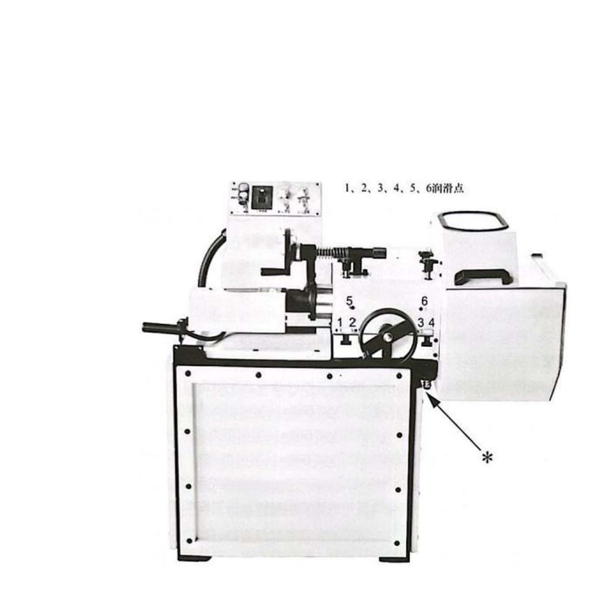

Use the method of the hand wheel
The equipment has two hand wheels in total, the high small hand wheel is transverse movement into the hand wheel, the hand wheel scale value of a small grid is 0.02 mm. Position from the lifting handle to the grinding wheel, turn the hand wheel clockwise, move the work piece (brake disc) to the right, and turn the hand wheel work piece (brake disc) counterclockwise to the left. The low large hand wheel is the longitudinal position moving hand wheel, the hand wheel rotation circle is 4 mm. Turn the hand wheel clockwise, move the workpiece (brake disc) forward, and move the hand wheel workpiece (brake disc) backward counterclockwise.

5.Start-up check, refuel the lubrication point, and confirm the rotation direction of the grinding wheel shaft and workpiece shaft.

Fill with lubricating oil
After the equipment installation in place, before the test in the lubrication point, in confirm no air in the refueling gun, to refueling point, 1,2,3,4 (rail lubrication) all refueling, the workpiece shaft component longitudinal move to the last end refueling twice, and then rotate the longitudinal handwheel, make the workpiece shaft components moved to the longitudinal front end refueling twice, and then the counterclockwise rotation Move the handwheel longitudinally to move the workpiece shaft assembly in place. Fuel the refueling points 5,6 (shaft sleeve lubrication), rotate the hand wheel horizontally, move the workpiece shaft assembly to the far left end, refuel the refueling points 5 and 6 three times, rotate the handwheel horizontally, move the workpiece shaft assembly to the far right end, and refuel the refueling points 5 and 6 three times.

Confirm the rotation direction of the grinding wheel shaft and the workpiece shaft
Before starting, confirm that there is no foreign body in the grinding wheel cover and workpiece cover, and the grinding wheel and workpiece shaft rotate flexibly and freely, and press briefly. Check whether the rotation direction of the mark and the workpiece shaft is the same as the cover. If inconsistent, adjust the power wiring, and repeat the test machine until it is consistent. After pressing the grinding wheel to start and press, quickly press the grinding wheel to stop the press. Check whether the rotation direction of the grinding wheel is consistent with the direction marked outside the cover. If inconsistent, adjust the power supply wiring and repeat the test machine until it is consistent.

Grinding brake disc operation steps, accuracy adjustment, common problems and solutions in the operation method.

Operation steps of grinding the brake disc
Release the four fixed hand twist bolt on the workpiece shaft moving components, move the workpiece shaft back to a safe position, confirm the brake disc and car hub bearing surface, smooth without foreign matter, confirm the positioning flange end surface smooth no foreign matter, holding the brake disc and the center, the brake disc end joint in the positioning flange end, then into the centering cone set, pressure plate, with the nut tighten (tighten torque approximate hub tightening torque). Use the dial to detect the beating amount of the brake disc and the car hub. If the beating amount can not exceed 0.03 mm, if it exceeds 0.03 mm, loosen the nut, turn the brake disc position, and adjust within 0.03 mm. Over 0.03 mm, it cannot be trimmed and polished, otherwise the brake disc may be scrapped.
According to fix the brake disc, turn transverse into the hand wheel, make the brake disc two working face in the middle of the two wheel gap, confirm the brake disc on both sides of the face and grinding wheel inside more than 1 mm distance, then turn the longitudinal position moving hand wheel, make the brake disc face edge and the grinding wheel diameter alignment, after alignment, clockwise turn longitudinal position move hand wheel (That is, moving forward 4 mm), when moving forward and vertically, pay attention to the maximum diameter of the brake disc, can not touch the grinding wheel shaft, after confirming that there is a gap between the two, tighten the four fixed hand torsion bolts of the workpiece shaft moving assembly.
Rotate the lateral feed hand wheel, Move the brake disc working face to about 1 mm at the end face of the grinding wheel (this work should be operated carefully and reliably according to experience), Then close the shield on the upper part of the grinder, Starting the grinding wheel and the workpiece, Through the viewing window, Observe the distance between the brake disc working face and the end face of the grinding wheel and slowly rotate the transverse feeding hand wheel, Put the brake disc working face into slow contact with the grinding wheel, A grinding spark, Entering the process of grinding the brake disc working face, At this time, slowly and intermittently turn the handwheel for grinding, The feed speed is about 0.1 mm per minute (5 small squares per minute), Note that the rotating lateral input hand wheel speed is adjusted empirically, Too fast will burn the brake disc surface and damage the grinding wheel, Too slow, the low grinding efficiency, After checking that the brake disc working face can meet the repair requirements, In maintaining a certain optical finishing grinding time, Seeing very small and scattered sparks between the brake disc working face and the grinding wheel, Slowly turn the hand wheel to exit the grinding process, Be careful not to touch the other side of the brake disc against the grinding wheel, Then by grinding this surface, Another working face of the grinding brake disc, After both working surfaces have been sharpened, Move the hand wheel horizontally, When there is a gap between the two working faces of the brake disc and the two inner ends of the grinding wheel, Move the hand wheel in the longitudinal position, Turn the brake disc back in place, With a percentageTable detects whether the beating value of the brake disc working face is closed. Remove the brake disc step from the grinder and perform the opposite work of the installation step.

Precision adjustment
Brake disc working surface grinding out mesh pattern, need very high machine shape position accuracy and working experience. If the ideal mesh pattern is not achieved during grinding, the tightening torque of the four fixed hand torsion bolts of the workpiece shaft moving assembly and the tightening sequence of the four bolts should be adjusted.

Common problems and solutions in the operation
In the brake disc grinding and repair work, the grinding does not reach the ideal mesh pattern. Move the four components against the workpiece shaft When the tightening torque of the fixed hand torsion bolt and the tightening sequence of the four bolts cannot be adjusted to produce the ideal mesh pattern, check for dirt between the moving assembly with the base rail of the workpiece shaft.
Grinding work, grinding wheel or workpiece suddenly stop rotation, also cannot start again, may be due to grinding force is too large, protect the motor thermal relay action stop, wait for a few minutes, can natural reset, or to grinder power including power supply, and then manually press the electrical box internal hot relay red twist, make its reset.
The grinding electrical appliances cannot work normally, the grinding machine must be powered off including the power supply line, please ask the professional electrician to check and remove the fault.

7. Daily maintenance and warranty terms

Daily use and maintenance of precision brake pad
During the use of the equipment, fill the following refueling points with lubricating grease according to the daily use frequency.1 / 2 / 3 / 4 lubrication point once in three working days (fill 40 # ordinary mechanical oil).5 / 6 Fuel once within five working days (fill in 40 # ordinary mechanical oil). Sand wheel spindle bearings, including four or five sets of bearings, clean and fill grease (white special grease # 2T) once in 180 working days. The grinding wheel motor bearing shall clean and fill the grease (white special grease no. 2 T) once in 180 working days. There are four sets of workpiece spindle bearings, clean and fill grease once in 360 working days (white special grease 2 T).
The workpiece shaft moving assembly and the base guide rail cooperated with it are cleaned and maintained once within 180 working days, and check whether the dust and scratch plates of the four guide rails are damaged or replaced. The workpiece cover has self - adhesive wool strips, which shall be replaced once within 180 working days. Move the rubber scraping plate in front of the dust cover of the upper part of the workpiece shaft to check whether there is any damage or replacement in time.
There is a ring of dust - proof self - adhesive wool strip under the movable cover of the upper part of the grinder. If it is damaged and old, it should be replaced in time, otherwise it cannot be dustproof.

Warranty terms
The equipment warranty period is one year. During the warranty period, one of the following conditions can not enjoy the warranty service
- Due to other non - resistance (such as flood, lightning strike, earthquake, abnormal voltage) caused by the damage.
- Damage caused by bad transportation after the purchase of our products.
- Without the consent of the company, the user removes, repairs, refit the products and other human factors and use in abnormal working environment, and damage caused by not using according to the instructions.
- The grinding wheel belongs to vulnerable consumables, not within the scope of warranty.

8.Attachment
Name | Qty.
50mm plum-shaped wrench | 1
30mm open-mouth wrench or  30mm plum-shaped wrench | 1
Magnetic universal table seat and a set of dial indicator | 1
Portable lighting lamp | 1
Refueling gun | 1
Lifting and handling handle | 1
Lifting and handling lever | 1
Equipment fixing bolts (fixing bolts for equipment and packaging base) | 4
Diamond grinding wheels of Dia. 250mm | 2

Note: No change in the product technical specifications will be notified separately.

